TRAVELX

M. Neehar Kumar  
*Department of Information&technology*  
*Vardhaman College of Engineering*Hyderabad-Telangana, 501286, India  
[mittapallyneehar3@gmail.com](mailto:mittapallyneehar3@gmail.com)

S. Madhulitha  
*Department of Information & technology*  
*Vardhaman College of Engineering  
Hyderabad-*Telangana, 501286, India  
[madhulithareddy2709@gmail.com](mailto:madhulithareddy2709@gmail.com)

G. Sai Vardhan  
*Department of Information & technology*  
*Vardhaman College of Engineering*Hyderabad-Telangana, 501286, India  
 saivardhangajengi06@gmail.com

Sai Nikhila Reddy  
*Department of Information & technology*  
*Vardhaman College of Engineering  
Hyderabad-*Telangana, 501286, India  
[nikhilaravipally@gmail.comg](mailto:nikhilaravipally@gmail.comg)

Mrs. Fatima Unnisa  
*Department of Electrical and Electronics Engineering*  
*Vardhaman College of Engineering*Hyderabad-Telangana, 501286, India  
[fatimaunnisa@vardhaman.org](mailto:fatimaunnisa@vardhaman.org)

*Abstract*—The public issue of confusion and excessive prices faced by personalities when selecting transportation paths, our group designed the app to provide detailed information on various travel options. The app, named TravelX, offers users a comprehensive view of possible routes using different modes of transport such as buses, autos, and metros, all within budget constraints. The project aims to address the challenges people encounter while booking services like Ola, Uber, and Rapido for their journeys. Through the app, users can access a range of route choices, enabling them to make informed decisions based on their preferences and financial considerations. The development process involved constructing the app with a focus on user-friendly features and efficient functionality. Additionally, a 2-minute video presentation was created to demonstrate the design, operation and benefits of the TravelX app. Overall, the project emphasize the importance of providing users with a convenient and cost-effective solution for navigating their travel needs.

Keywords—Tracking, Geo-Location and Support.

# Introduction

In latest way of life, by fast growth of product intake, the bazaar atmosphere and manufacturing organization have transformed seriously, logistics and shipping troubles have become further tricky [7]. India has an extensive choice of tourism crosswise the terrain, where individual be able to acquire to the entire special objective [13]. More than 3 millions client Indians speedily tailored mobile Applications. Even though realistic significance, the prose on travel apps is spotted and hardly ever recognizes the implementation manners in rising financial system. By means of expansion in information and skills, comprised a ‘mobile strategy’ for production expansion is remarkable. Over Period of moment, universal tourism zone digitally extended via tour Apps to grab various bazaar sectors (Chatterjee 2021). Travels apps hold modernize the mode business continue client affairs via suggesting them to adapted knowledge (Lai 2015). Additionally, the COVID-19 pandemic includes reproduces in employment of internet as well as travel associated apps [19].

The growth in worldwide transportation as well influences the level of local transportation process [10]. A multimodal mean of transport depend on several of shipping and incorporates the uniqueness of a variety of shipping, which progress transportation proficiency and diminishes shipping charges and becomes the spotlight of investigator exploration [8].

Multimodal transport is a current way of transporting load via synergizing further types of shipping [9]. The important association are (i) the culture of scheme to reduce the capacity of extreme end of the timorousness poly tope that should be restrained in the form and (ii) the presentation of a cutting level outward procedure for the path difference construction to resolution the strong case as just as the settled [11]. Expected the growing smart phone use rate in modern years, mobile handset tasks (apps) can be noticeably affect trades [16].

The usage of matter is based on flexibility organization plans were advised already in the starting of the time but only in the last period has achieved momentum [18]. Over time, the universal travelling area digitally extended through travel apps to seizure various market segment [19]. The travelling apps business is developing and has progressive, with 100,000 apps in the app store and a similar amount in the Google Play Store [20].

# Literature Review

Deepthi et al., The tour app promote is booming, excluding lots of apps spotlight on single task like maps or booking. Traveler efforts to locate suitably broad tour data. This app crack via creating affluent and direct contented (text, pictures and videos) used for client toward discover traveler target superior [1].

D. Irawan et al., Boost in traveler visit toward South Sumatra have lead to a need of instruction regarding traveler target point and shipping. This need of instruction might lead near a turn down in traveler visits to the region. The South Sumatra government has projected a mobile travel guide app to facilitate the direction problems. The app would offer traveler through instruction regarding lodging, and transportation in the region [2].

Alexander Smirnov et al., traveler frequently besieged by the absolute amount of tour apps existing. This article labeled these apps and suggests "Tourist Assistant" an AI powered app which suggests magnetism supports on the client spot and choice. TAIS extracts instruction from diverse internet resources, offers a broad database of target point. This is a charming case study in relating AI to develop the tour skills [3].

Lingyun Wei et al., to improve shipping directions and methods in multimodal networks, an incorporated copy including a variety of things (price, time, schedules, jamming, etc.) be build up. A better algorithm through time pane vigorously chooses best possible direction and method via a biased assessment task. Mathematical testing verified its efficiency and compliance [4].

Queen Mary et al., Mobile apparatus through internet unchain novel sightseeing assistance - anytime, anyplace. Spot based realization is key. Client research is critical to corroborate this assistance and guarantee client agreement for a victorious hope [5].

Alexander Maedcheet al., Assistance Architectures proposed elasticity excluding deficiency of superior assistance innovation. This article suggested network assistance, homologous and syntactic network to expand young generation assistance scheme by enhanced automation and innovation [6].

TieZhang et al., This scheme is practical, with key period under a few seconds with the point in time for network measurements, and has previously been deployed. Octant opens up the opportunity of enable network operators to settle on node position on-demand exclusive of resorting to undependable and imprecise IP-to-ZIP databases. It expect that precise data on node spot will be used for adapted content delivery, system management and network diagnosis, without compromise consumer privacy [9].

Dickinson, J.E et al., This paper projects stuff relevant to a speedy affecting technical field, the investigation is partial to a exact spot of time and appointment speedily as the capability of smart-phones develop rapidly. The paper’s intent is afterward mainly to sketch concentration to a existing matter of consequence to explore industry. Public is at a spot of evolution where cultural technological strategy are sprouting innovative tour perform which may bind to undertake fashionable tour troubles [17]. While technological yields depict will raise and consequently necessitate innovative conceptualization, it is hope that the paper will kindly attention and investigation to grab the possibilities to facilitate smart phones afford to decline travel linked CO2 discharges.

Rajiv Mishra et al., The in attendance study identified the factors influencing customer travel acquire intention. The prime goal of this investigation is to establish the Indian users to travel applications can use the boundaries derived from the lingering combined theory of receiving and usage of technology with supposed trust as a mediating variable. The article further addressed the pragmatic findings and implications of no-nonsense work to the termination of this investigation. This investigation seeks to fill the recent research vacuum caused by a need for more empirical studies. It tries to grasp the elements influencing customer’s propensity to purchase travel-related commodities via travel applications [20]. The study puts up a explore model based on the UTAUT2 framework. The UTAUT2 standard is extended by adding supposed trust as a mediating variable and secretarial for customers' purchase intentions as a final needy variable. The results indicate that all five are supported among the four constructions. The results reveal that EE had the most significant impact on acquire intent, followed by FC, PE, and SI. Overall, these works benefits travel submission businesses in promote their communal and marketing objectives.

III. FLOW ANALYSIS

This section will describe the flow analysis of TravelX App using the flow chart in which customers can visit and use mobile to show system.

First assumed that the portable client encompasses previous records with the arrangement and supply their individual facts. Figure 1 explained the operational flow of application in particular. In step-1, step-2, step-3 the portable phone clients record on scheme via portable search engine on his/her portable tool and drive appeal to the squash out server. To react, the squash out up server precedes a network sheet to the portable search engine.

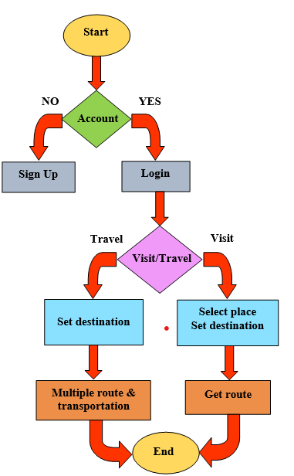

Fig 1. Flow diagram of TravelX App.

Concurrently, the search engine is activated GPS (Global Position System). It will be essential to attach regulator to the search engine, consequently GPS was capable to renovate client’s geological spot instructions to squash out server within the occasion. In Step-4, an ecological spot instruction of mobile client is carried out to squash out server. Meantime, the client’s instruction is also drives to squash out server.

In step-5, squash out server investigate the client instruction store in the catalog to attain the client’s inclination necessities. Concurrently, as the material of Yahoo Travel is in English, Mash-up server conclude whether it is essential to employ the conversion software throughout the investigation.

In step-6 and 7, the Geo-coding Widget on Mash-up server primary transmits the client’s geological position instructions into altitude and azimuth values. Then these values are carried to Google Maps Server via mash-up server throughout REST protocol.

IV. EXISTING SOLUTION

Existing portable services are improving by means of spot conscious characteristics, offering the clients with enhanced employ of knowledge. An enormous quantity of cell phone applications emerge newly, Lots of them are spot correlated.

The analysis speaks mobile has capability to get accurate position from the specific favorites, existing position, map, space among two metropolitans, weather description. Taken out from the investigation that numerous applications have been expanded, excluding a few number of traveler information data is primarily attained via newspaper, magazines etc. An application doesn’t offers accurate instruction when customer is moving.

Spots conditional services that reply Spots conditional doubts as well as significant course group of adaptive applications. By means of variety of applications such as limited instruction attain (traffic circumstance, routing communication etc) and nearest atmosphere doubt like tracing the adjacent café, site reliant doubt service will rapidly turn into an essential element of our everyday survive.

The estimation description by mobile is capability to catch exact spot from the exact beloved, modern spot, map and space among two metropolises, climate description, locate the record. Mention from the study that several functions have developed so far, except a few of visitor instruction is mostly attained via broadsheet; journals application doesn’t offer accurate instruction as client on journey.

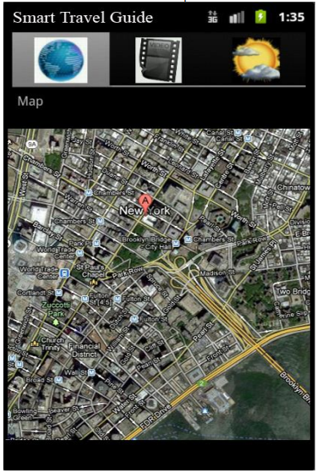

Fig 2. Trace the client in chart

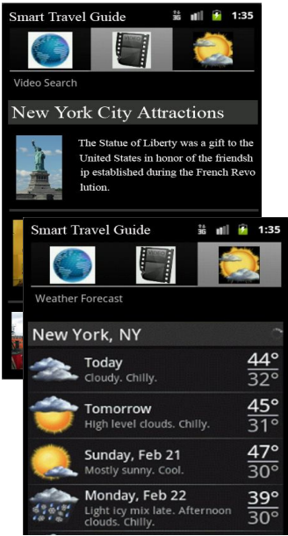

Fig 3. seek videos as per client’s existing spot and

Climate predict for spot.

After learning countless investigated articles and also speak a lots of difficulty except few declared above is the foremost matter. So the projected scheme will seek to resolve several troubles associated with existing spot, map, space among two metropolitans, climate description, locate the video. To assist the client who is new to the metropolitan at the roaming moment and acquire existing spot, map and space connecting two metropolitans, weather information, locate the video as shown in figure 2 and 3.

1. PROPOSED SOLUTION

The projected method of application has so many benefits demonstrated as: reach our destination very easily, the time taken by each transport will be shown clearly. To reach our destination, the price of each transport resolves clearly. It’s implemented save our soul (SOS). When press the SOS button it will transmit the spot to the hospital and nearest police station and also implemented chatbot. it will book the transport as well as it answers all the questions asked by the customer regarding travel. App employs dissimilar types of transport like auto, bus, metro within the budget to reach destination. It will highlight the famous places in your way to destination. It will show different types of routes like shortest path, lowest price taking path etc.

# Results

To address the challenges faced by travelers in reaching their destinations by providing detailed information about routes, transportation options, and optimized paths.

Step-1: Login

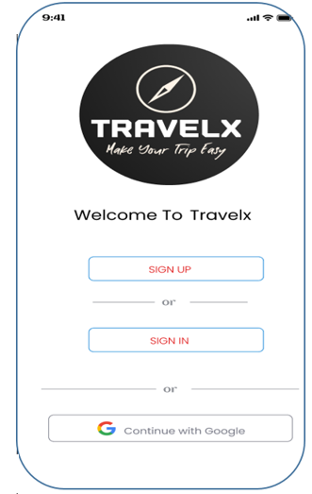

Fig 4. Login page

Figure 4. demonstrate how to enter into Application each individual has to login or signup here.

Step-2: Sign in

Figure 5 described the customers how to Sign in sheet identifies the login URL in an internet domain that customers should passing through, to acquire to the genuine URLs at the spirit of the purpose.

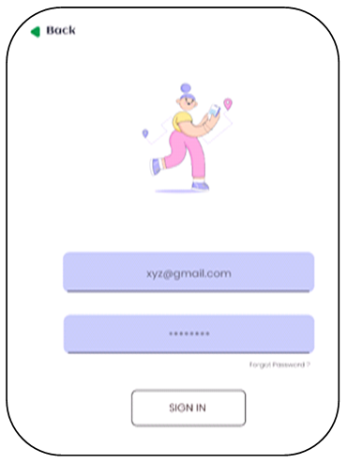

Fig 5. Sign in page

Step-3: Sign up

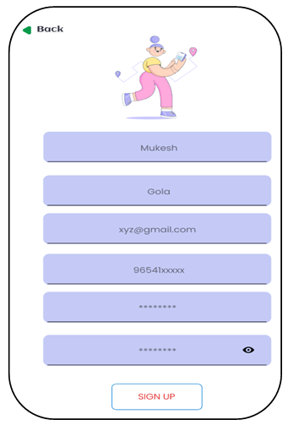

Fig 6. Sign up page

Figure 6 says to sign up with the App every individual must give the address and details of the traveler.

Step-4: Choosing preference

Figure 7 shows in the above figure describe the visitor will choose the type of route they needed either travel/visiting.

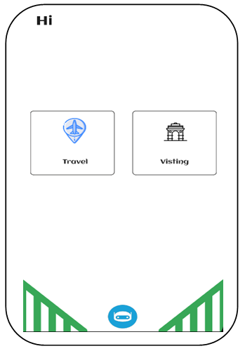

Fig 7. Choosing routes page

Step-5 Selection of SOS button

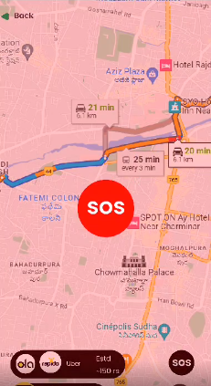

Fig 8. Save our soul (SOS) button.

Figure 8 describe the save our soul (SOS). When press the SOS button it will transmit the spot to the hospital and nearest police station and also implemented chatbot.

Step-6: choosing routes

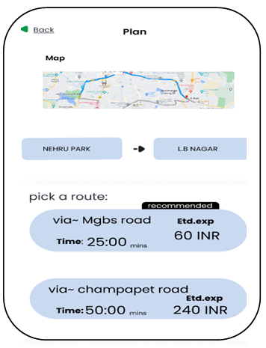

Fig 9. Showing the possible routes page

Figure 9 describes, after choosing the references it shows the route, now select from where the traveler wants to go by assuming time and distance.

Step-7: Showing direction

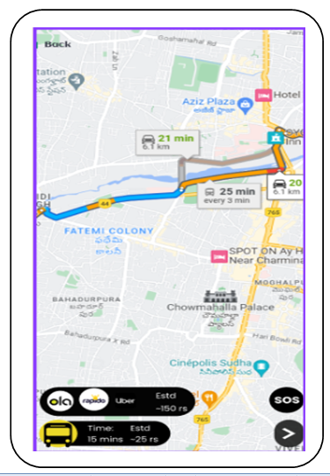

Fig 10. Showing the possible transportation

Figure 10. Concludes the destination of the traveler in a better approach.

It also highlights the benefits of the app, such as cost and time estimation for each mode of transport, as well as the ability to reach the destination within the user's specified time and budget. The challenges towards implementation of the app may include technical complexity, data integration, security and privacy considerations, user adoption, monetization, regulatory compliance, and ongoing maintenance and updates.

# Conclusion

Through travelx, customers can finally enjoy detailed information about your trip, travel in less time and especially feel secure, make your payments faster, travel in fewer budgets. In conclusion, Travelx is an app to provide detailed information about your trip, help you travel in less time, feel secure, make your payments faster, and travel within your budget.

The app shows all possible routes with different means of transport like buses, auto, metro, etc. It also provides optimized routes from the source to the destination. The app was designed to address the common problem of people getting stuck while traveling and not having access to complete details and optimized paths. With Travelx, users can finally enjoy a hassle-free travel experience.

##### References

1. Deepthi, Gayathiri, Latha sree and Leena Raj, "Smart Travel Guide Application For Android Mobile", JETIR, Volume 8, Issue 4, April 2021.
2. U. Ependi, M. Bunyamin, A. Muzakir, D. Irawan Fatoni and I. Effendy D. Irawan, "Model For Mobile Application Development On Traveling Guide: A General Proposal", International Conference on Electrical Engineering and Computer Science (ICECOS), pp. 122-126, 2019.
3. Alexander Smirnov, Alexey Kashevnik, Nikolay Shilov, Nikolay Teslya and Anton Shabaev, "Mobile Application For Guiding Tourist Activities: Tourist Assistant," in Proceeding of the 16th Conference of Fruct Association, December 2014.
4. [Yan Liu](https://www.researchgate.net/scientific-contributions/Yan-Liu-2143998381?_sg%5B0%5D=fV9-cYhYG3dxN0vzjqkOWTfISfzqPj84LhXW6AVgspMsXRy7Mp9tsjHFdgkffK7I2-Rk2sE.R4f_1ScSICLh_XzeYzHN3DaEgKQEiH3dEb8jHCMF4OoCcgv9RTonuZPrs2oQNZScjAa91KNUIzk_HzoNodOUKw&_sg%5B1%5D=9267Ff04Ran_-9ePO9sXCUf6TfwX9LGwhFo3zxhBnLjcGANZpPqdiu0PNCrlv-ORv1y71hI.e5uqixQYT8peu6JoRSXUchhFW_EIdXi1ekN1lWlKuyIx9AljGTe4rpw1YQplvlav1NEetDFTZLjwiuzRkkUznA&_tp=eyJjb250ZXh0Ijp7ImZpcnN0UGFnZSI6InB1YmxpY2F0aW9uIiwicGFnZSI6InB1YmxpY2F0aW9uIiwicG9zaXRpb24iOiJwYWdlSGVhZGVyIn19)and Lingyun Wei, “The optimal routes and modes selection in multimodal transportation networks based on improved A* algorithm”, 5th International Conference on Industrial Engineering and Applications (ICIEA), 2018.
5. B. Wong, I. Stoyanov, E.G. Sirer. “Octant: A Comprehensive Framework for the Geo-localization of Internet Hosts”, In Proceedings of the Symposium on Networked System Design and Implementation, Cambridge, Massachusetts, April 2007.
6. Dan. Li, J. Cheny, C. Guo, Y. Liu, J. Zhangy, Z. Zhang and Y. Zhang, “IP-Geolocation Mapping for Involving Moderately-Connected Internet Regions”, IEEE Transactions on Parallel and Distributed Systems, Febuary 2013.
7. Lin Li, Qiangwei Zhang, Tie Zhang, Yanbiao Zou and Xing Zhao,“Optimum Route and Transport Mode Selection of Multimodal Transport with Time Window under Uncertain Conditions” Mathematics, July 2023.
8. Ming-fei Chen, Yan-qiu Liu, Yang Song, Qi Sun and Chuang-chuang Cong, "[Multimodal Transport Network Optimization Considering Safety Stock under Real-Time Information](https://ideas.repec.org/a/hin/jnddns/5480135.html)", [Discrete Dynamics in Nature and Society](https://ideas.repec.org/s/hin/jnddns.html), Hindawi- Discrete Dynamics in Nature and Society, July 2019.
9. Tie Zhang, Jia Cheng and Yanbiao Zou, “Multimodal transportation routing optimization basedon multi-objective *Q*-learning under time uncertainty”, Complex & Intelligent Systems, January 2024.
10. Emrah Demir, Wolfgang Burgholzer, Martin Hrušovský, Emel Arıkan, Werner Jammernegg and Tom Van Woensel a, “A green intermodal service network design problem with travel time uncertainty. Transportation Research. Part B, pp. 789–807, November 2015.
11. A. Agra, M. Christiansen, R. Figueired, L. M. Hvattum, M. Poss and C. Requejo, “The robust vehicle routing problem with time windows”, Hal Open science [Volume 40, Issue 3](https://www.sciencedirect.com/journal/computers-and-operations-research/vol/40/issue/3),  pp. 856-866, March 2013.
12. Alexander Smirnov, “Mobile Application for Guiding Tourist Activities: Tourist Assistant – TAIS” Proceeding Of The 16th Conference Of Fruct Association, December 2014
13. Dhanashree Badhe, Pallavi Regundawar, Vaishnavi Todkar and Ravindra Kale, “An Indian Tour Advisor App”, International Journal of Innovations in Engineering and Science, Vol. 7, Issue 9, PP. 71-75, August 2022.
14. Jiaying Lu, Zhenxing Mao, Mengbin Wang and Liang Hu, “Goodbye maps, hello apps? Exploring the influential determinants of travel app adoption”, Current Issues in Tourism, Vol. 18, Issue 11, pp. 1059– 1079, September 2015.
15. José Magano, “Mobile Apps and Travel Apps on the tourism journey”, African Journal of Hospitality, Tourism and Leisure, Volume 8 (5) - (2019) ISSN: 2223-814X, 2019.
16. [Sia, Phoebe Yueng-Hee](http://myscholar.umk.edu.my/browse?type=author&authority=rp02106&authority_lang=en_US)  [Saidin, S. S.](http://myscholar.umk.edu.my/browse?type=author&authority=rp02106&authority_lang=en_US)  [Iskandar and Yulita Hanum P](http://myscholar.umk.edu.my/browse?type=author&authority=rp10091&authority_lang=en_US),” Systematic review of mobile travel apps and their smart features and challenges”, Journal of Hospitality and Tourism Insights, Vol. 6 No. 5, pp. 2115-2138, December 2023.
17. Dickinson, J.E., Ghali, K., Cherrett, T. and Speed, C., Davies, N and Norgate, S, ”Tourism and the smartphone app: capabilities, emerging practice and scope in the travel domain”, Current Issues in Tourism. Vol. 17, Issue 1, pp. 84-101, 2014.
18. Dastjerdi, A. M., Kaplan, S., de Abreu e Silva, J., Anker Nielsen, O., and Camara Pereira, F. (2019). “Use intention of mobility-management travel apps: The role of users goals, technophile attitude and community trust. Transportation Research Part A: Policy and Practice, Vol. 126, pp. 114-135, 2019.
19. Rahul Pratap Singh Kaurav, “Understanding travel apps usage intention: findings from PLS and NCA”, 6 September 2023.
20. Rajiv Mishra, “A Study on Consumers’ Travel Purchase Intention Through Travel Apps”, Prabandhan: Indian Journal of Management, July 2023.
21. Mobile Application for Guiding Tourist Activities:
22. Tourist Assistant – TAIS
23. Mobile Application for Guiding Tourist Activities:
24. Tourist Assistant – TAI